VIDEO - Startup Boards: Recruiting Your Board Members

Startup Boards: Recruiting Your Board Members
Video: https://www.youtube.com/watch?v=4Pz107X44Ps

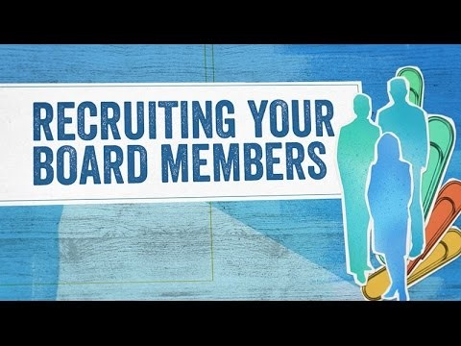

Have a wide lens. In this video, Brad Feld explains how it’s very easy to think about your own direct network, people you know or investors that invest in your company, and then go only one degree further. Thinking about recruiting board members in the early stages is powerful.
THIS VIDEO CAN HELP ANSWER:
Who should I start forming a relationship with in looking ahead to potential board members?
How do I recruit a board member?
How could I audition a potential board member to see if they're a good fit on my board?
ABOUT THE KAUFFMAN FOUNDERS SCHOOL
Visit the website: [http://bit.ly/1EW2br7]
The Kauffman Founders School presents a powerful curriculum for entrepreneurs who wish to learn anywhere, anytime. The online education platform features experts presenting lectures in series modules designed to give Founders a rich learning experience, while also engaging them in lessons that will make a difference in their business today, tomorrow, and in the future.
The Kauffman Founders School series modules include Powerful Presentations, Intellectual Property, Founder's Dilemmas, Entrepreneurial Selling, Entrepreneurial Marketing, Surviving the Entrepreneurial Life, Startups, and much more.
© Ewing Marion Kauffman Foundation.

Aus <https://www.youtube.com/watch?v=4Pz107X44Ps>

